CTM-I Use Case

Firm TCP/IP Socket Password

Version 0.1

Use Case Name | Firm TCP/IP Socket Password
Actor | Firm, Trader, CBOE USER
Pre-conditions /Assumptions | User has Browser and is aware of the http path to the application.  User has successfully logged into the CTM-I application.  User has the right role to see the menu options.
Post Conditions | None
Screenshot | 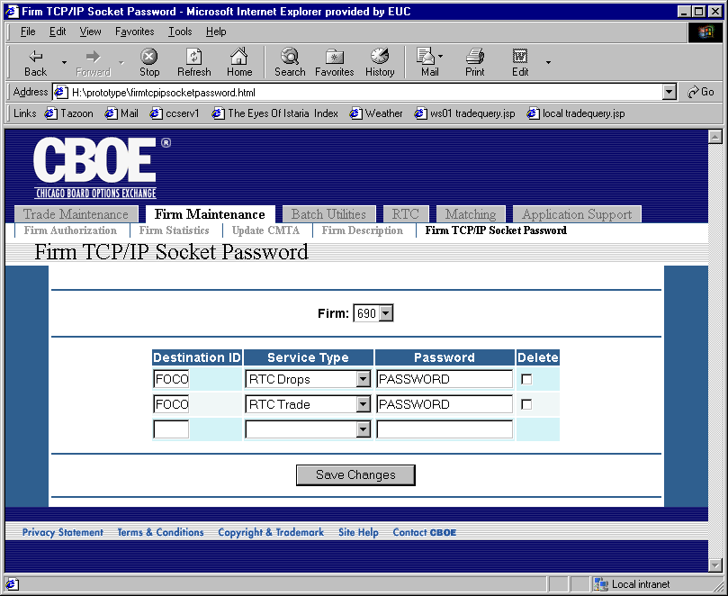
Flow of Events | - User selects “Firm TCP/IP Socket Password” from the menu.  - Firm TCP/IP Socket Password screen appears.  - User selects a firm from the list of firms  - Selecting the firm will cause a request to be sent to CTM-R to retrieve the current TCP/IP Socket Passwords for the firm.  - The list of TCP/IP socket passwords will be displayed.  - The data displayed will be as follows  - Destination ID  - Service Type  - Password  - The user will be able to add a new row, delete a current row, or edit the data on a row.  - Service Type will be limited to the list of possible values (RTC Drops, RTC Trade, Outbound Network, Stock Futures, Match Notification, Real Time Clearing, Valid Series).  - The user will press the “Save Changes” button to save the changes.  - Changes will be passed to CTM-R for processing.  - The results from CTM-R will be presented to the user.
Alternative Path | 1. If the user changes data, then tries to change firms, the user will be prompted with a confirmation to lose their changes.

